International Land Alliance Unveils New Revenue Model Featuring 100 Rental Homes in Cabo Oasis. Strong weekend sales continue to be reported at Cabo Oasis as well as Rancho Costa Verde


SAN DIEGO, CALIFORNIA, July 16, 2025 -- International Land Alliance, Inc. (OTCQB:ILAL), (“ILAL” or the “Company”), an international land investment and development firm, today announced a new planned phase at its Cabo Oasis development. With the engineering and interior roads already completed, the Company plans to begin offering this rental property product in the next 45 days.

“The market for rentals in Baja is in high demand and we will be meeting that demand with this new phase,” said ILAL president Frank Ingrande. “Not only is this a natural conduit for subsequent sales but will provide recurring rental revenues in addition to management fees. We have added a new marketing team with offices in Las Vegas and Northern California to focus on the new rental and sales phases. We have worked with this team that will now be operating in Las Vegas and Northern California for over 20 years and are excited to add this new inventory to their product offering. We have already started our weekly informational dinner seminars in Las Vegas and had our first on site sales tour.”

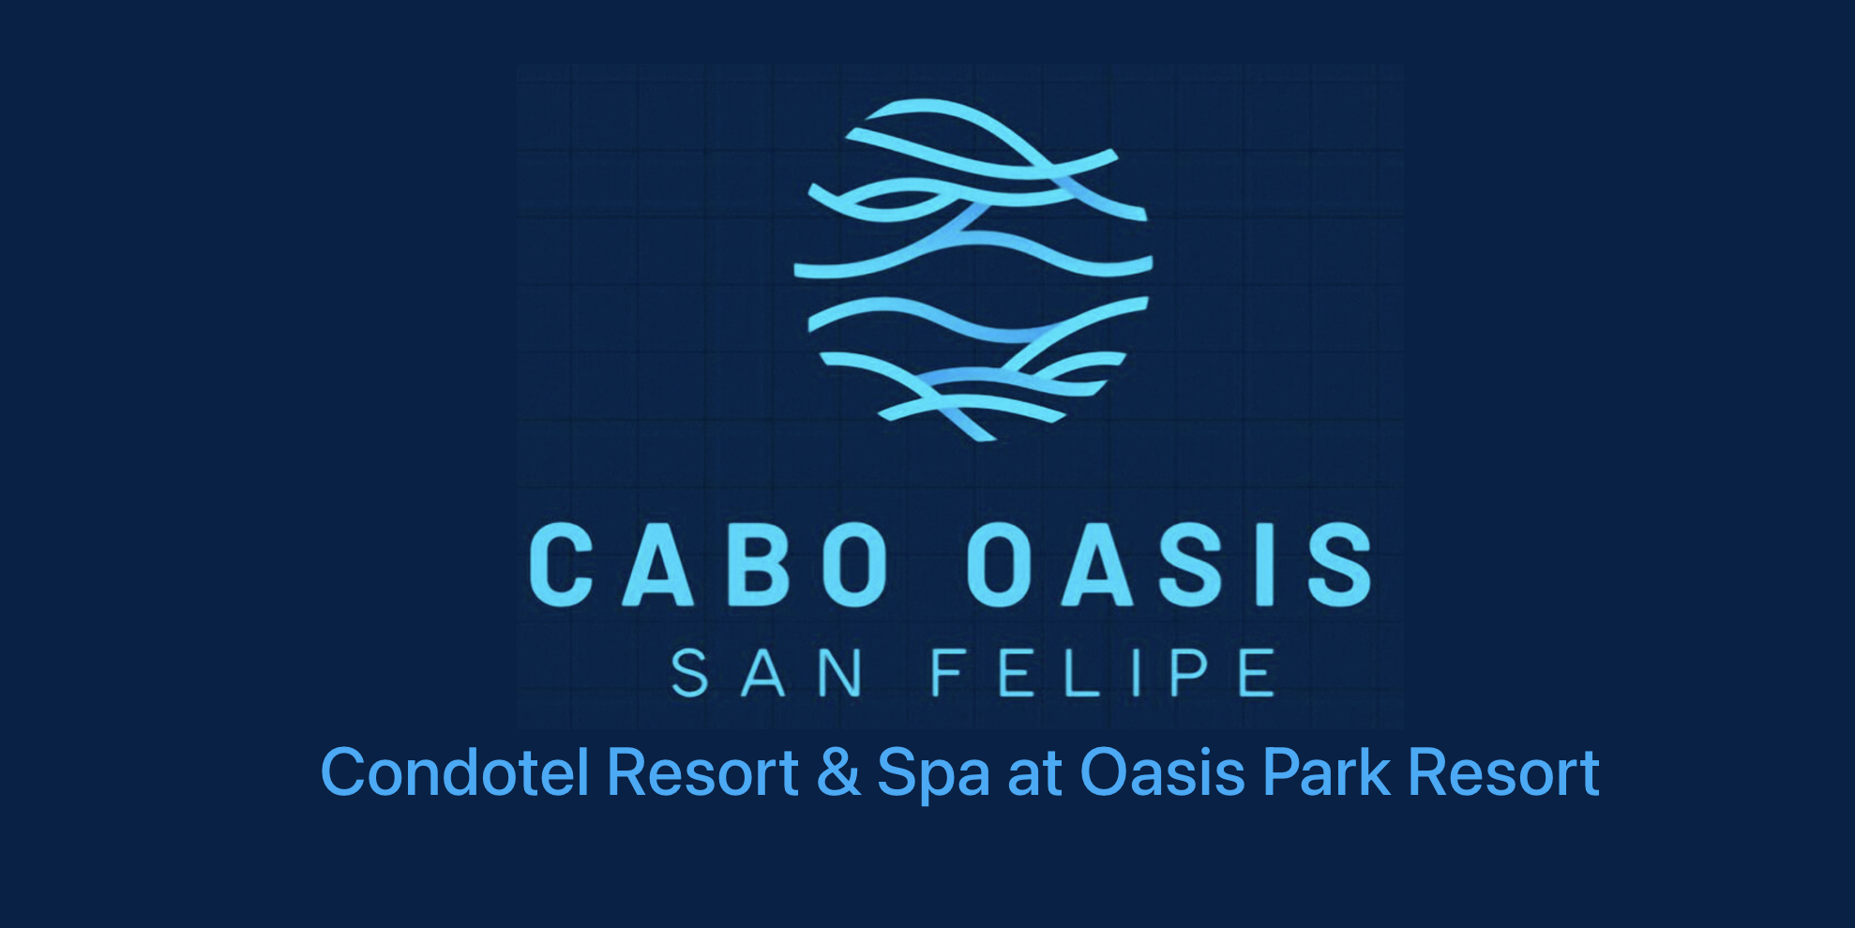

Sales continue to be strong for ILAL as the sales team reported 8 new homesite contracts signed over the weekend, including 4 contracts from newly released inventory at Cabo Oasis. With the beachfront inventory sold, the Company has released and opened for sales sites in Oasis Phase II, which comprises 200 homesites with an average price of $30,000. Four additional sales contracts were reported from Rancho Costa Verde homesites.

As previously announced, the Company reported sales at Cabo Oasis of 23 beachfront lots average price entry prices of $80,000 each and 5 new homes in the contract stage. The new homes are being built on beachfront homesites adjacent to the planned 72-room condotel on the beach fronting an existing natural lagoon at Cabo Oasis. This will serve as a flagship amenity for owners at both Rancho Costa Verde and Cabo Oasis. This Sante Fe style design will be a scaled-up version of the existing boutique hotel at Rancho Costa Verde. The total construction revenue for these first five homes is projected to be in excess of $1.3M, with the first home expecting break ground in August 2025.

The Company opened up sales at its Cabo Oasis, a master planned community located just eight kilometers south of Rancho Costa Verde in San Felipe, Baja California. With 500 homesites available for development, this represents over $15,000,000 in gross lot sales potential, followed by over $125,000,000 in gross potential construction revenue.
About International Land Alliance, Inc.

International Land Alliance, Inc. (OTCQB: ILAL) is an international land investment and development firm based in San Diego, California. As its’ core mission, the Company has embraced technology for sustainable and socially responsible solutions, in addition to using proptech and construction tech advanced applications to meet these goals. The Company is focused on acquiring attractive raw land primarily in Northern Baja California, often within driving distance from Southern California. The Company serves its shareholders by devoting considerable time and resources to seeking out the finest sites available and obtaining the necessary development permits to build a compelling portfolio of properties, which provide a diversity of investment and living options. Please visit: www.ila.company.

Safe Harbor Statement
The press release may include certain statements that are not descriptions of historical facts but are forward looking statements within the meaning of Section 27A of the Securities Act of 1933 and Section 21E of the Securities Exchange Act of 1934. These forward-looking statements may include the description of our plans and objectives for future operations, assumptions underlying such plans and objectives, and other forward-looking terminology such as "may," "expects," "believes," "anticipates," "intends," "projects,” or similar terms, variations of such terms or the negative of such terms. There are a number of risks and uncertainties that could cause actual results to differ materially from the forward-looking statements made herein. Such information is based upon various assumptions made by, and expectations of, our management that were reasonable when made but may prove to be incorrect. All such assumptions are inherently subject to significant economic and competitive uncertainties and contingencies beyond our control and upon assumptions with respect to the future business decisions which are subject to change. Accordingly, there can be no assurance that actual results will meet expectations and actual results may vary (perhaps materially) from certain of the results anticipated herein.

CONTACT:
Amplifi PR
Erik Blum / Erik@AmplifiPR.com

